**Load the CSV file:**

data <-read.csv("E:\\TYCS\\DataScience\\Political_Interest.csv")

attach(data)

|  |  |  |  |
| --- | --- | --- | --- |
| Gender | PoliticalInterest | Education | EconomicalCondition |
| Male | 60 | Bachelor's Degree | Middle Class |
| Female | 75 | Master's Degree | Upper Class |
| Male | 40 | High School Diploma | Lower Class |
| Female | 55 | PhD | Upper Middle Class |
| Male | 70 | Associate Degree | Upper Middle Class |
| Female | 45 | Some College | Lower Class |
| Male | 80 | Doctorate | Upper Class |
| Female | 30 | High School Diploma | Lower Class |
| Male | 65 | Master's Degree | Upper Middle Class |
| Female | 50 | Bachelor's Degree | Middle Class |
| Male | 55 | Some College | Lower Class |
| Female | 70 | Doctorate | Upper Class |
| Male | 35 | High School Diploma | Lower Class |
| Female | 60 | Associate Degree | Middle Class |
| Male | 45 | Bachelor's Degree | Lower Class |

**Plot the boxplot:**

boxplot(PoliticalInterest~Gender)

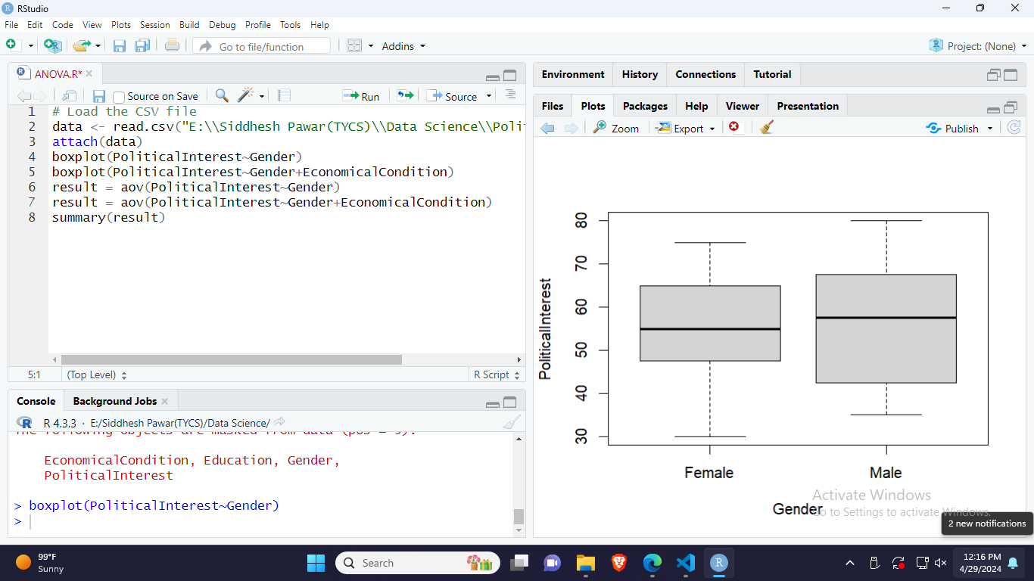

**Generate summary:**

result = aov(PoliticalInterest~Gender)

summary(result)



**Plot the boxplot:**

boxplot(PoliticalInterest~Gender+EconomicalCondition)

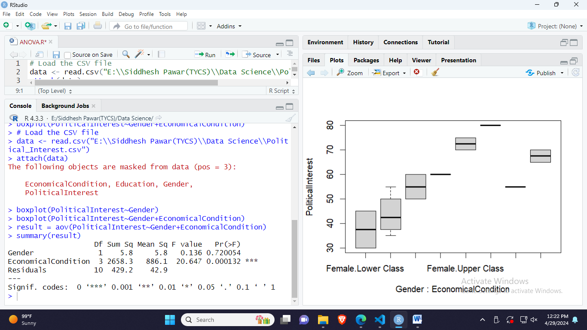

**Generate summary:**

result = aov(PoliticalInterest~Gender+EconomicalCondition)

summary(result)

